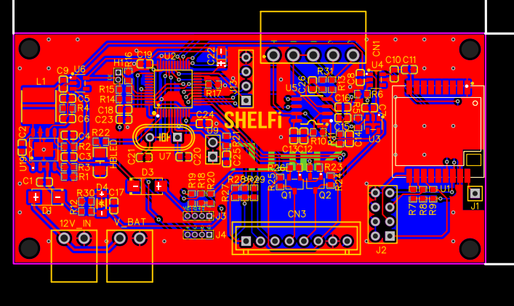
5

4
3
2
1

- 12V Power supply input.
- 12V battery input (range from 11.1v to 12.4v).
- Calibrator connector.
- Lora UART & Programming.
- Loadcell Input.

